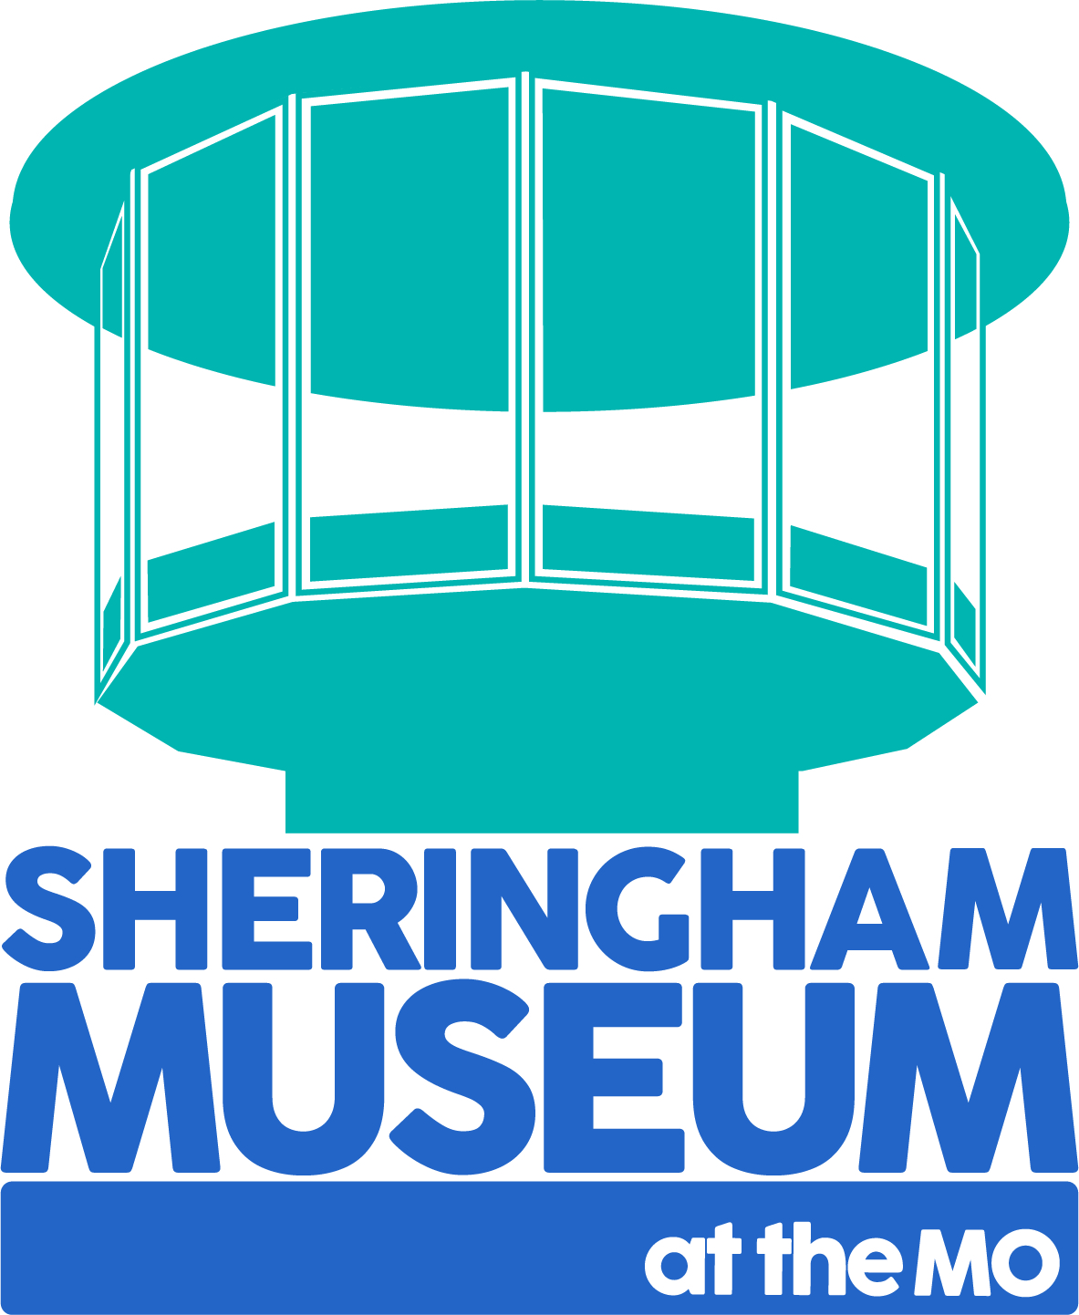 | Sheringham Museum Education Visit Booking Form  (Please complete & return)
Date of visit |  |  | Date: Arrival: Departure:
Name and address of group
Group details  (32 maximum for a workshop session) |  |  | Number:  Key Stage: Year
Contact name for visit
Telephone number or email
Special requirements/shop/ disabled access
Details of your activity |  |  | Please note your museum entrance is included in the cost
Visit Options |  |  | Please tick box | Cost
Teacher led self-guided KS1 & KS2 |  |  |  | £2.50 per student
Teacher led and assisted tour with short quiz sheet KS1 & KS2 |  |  |  | £3.00 per student
Teacher led KS1 or KS2 tour with children’s guide booklet 1 copy per child |  |  |  | £3.50 per student
Sheringham Develops workshop with quiz sheet, led by education team volunteer (1.5 -2 hours max.) KS1/2 & 3 |  |  |  | £5.00 per student
Advanced level group visits with handling objects |  |  |  | £4.00 per student
Advanced level changing Places workshop with handling objects |  |  |  | £5.00 per student
Please note that there is a minimum charge for a workshop of £50.00
TOTAL COST OF YOUR VISIT |  |  |  | £
There is no charge for teachers/carers who are accompanying the group. (4 adults per 30 pupils minimum)
Self-led visits are free to the Windfarm Visitor Centre and Tower during normal season opening dates
If possible, we would prefer to be paid in advance, but payment can be made on the day by cash, card, or cheque. Cheques should be made payable to ‘SHERINGHAM MUSEUM’. We can also invoice your establishment if you wish to pay by BACS. Please let us know which you would prefer.
If arrival time is before 10.00am OR out of season, PLEASE BRING YOUR GROUP TO THE SCHOOLS ENTRANCE AT REAR ENTRANCE OF THE MUSEUM. THIS IS LOCATED ON LIFEBOAT PLAIN. NR26 8BG
Facilities Information
Museum shop |  | If you are intending to visit the shop, please allow time for this within your visit.  Many items cost under £1.
Disabled Access |  | Lifts are available to each floor of the Museum, except the viewing tower.  Our access policy is available on our website or request us email a copy to you.
Toilets |  | Toilet facilities are located on the ground floor & next to our Top Deck on the top floor.
It is advisable for staff to book a free pre-visit wherever possible to familiarise themselves with the facilities and complete a risk assessment.
Group leaders are expected to supervise students at all times and ensure that expectations regarding behaviour are outlined prior to the visit and reinforced during the visit.
There will be a cancellation fee of 50% of your visit costs if you do not provide at least 5 working days notice.
Prices are current as of 12 May 2022.
We accept payment on arrival, cash or credit card- or via invoice, please indicate method of payment on returning this form.

Sheringham Museum currently offers two types of school visit. These are: ‘teacher led’ visits or workshops which support students at KS1 and KS2 and also at ‘A’ level.
A visit to the museum can raise awareness of the past and of how that past shapes our future.

Teacher Led
- Teacher led self-guided £2.50 per student
- Teacher led and assisted tour with short quiz sheet £3.00 per student
- Teacher led with museum children’s guidebook £3.50 per student
When a visit is ‘teacher led’ the students can investigate the museum with the aid of a child centric museum guide and/or with age-appropriate worksheets. We have a great deal to offer, not only with our impressive lifeboat and fishing boat collection but there are many objects, art works, photographs and oral records that help to develop an understanding of the town and its past.

Workshops
- Sheringham Develops key stage 1 with quiz sheet £4.00 per student
- Sheringham Develops key stage 2 with quiz sheet £4.00 per student
- A level changing Places workshop £5.00 per student
Our workshops for KS1 and KS2 cover the ‘Development of Sheringham.’ Students discover how what was once a small settlement, mentioned in the Domesday Book, grew over the next 1000 years into a thriving tourist destination. After short presentation students are able to explore the museum and use their worksheets to consolidate learning. Students will also have the opportunity to handle and explore specific historical artefacts.
At Advanced Level, students can investigate the changing environment of Sheringham as it developed over a 1000-year period including how Sheringham’s physical geography shaped the local economy, character, and nature of the town. Our collection provides for source-based study, discovery of the building of communities and can aid in gaining an understanding of chronological change.
Sheringham Museum is an ideal space for students to learn. It can aid understanding the past in a variety of ways and a visit to the museum provides a unique setting for teachers to engage their students with memorable and immersive learning.

